CONSERVATION CHRONICLE

***Created by: Brigitte Wierzbicki, Lead Conservation Steward – Ganondagan State Historic Site***

HOOP HOUSE FUNDRAISER MET!

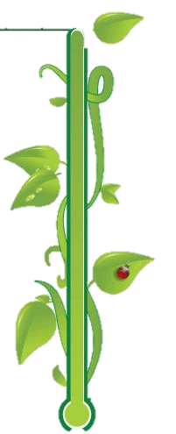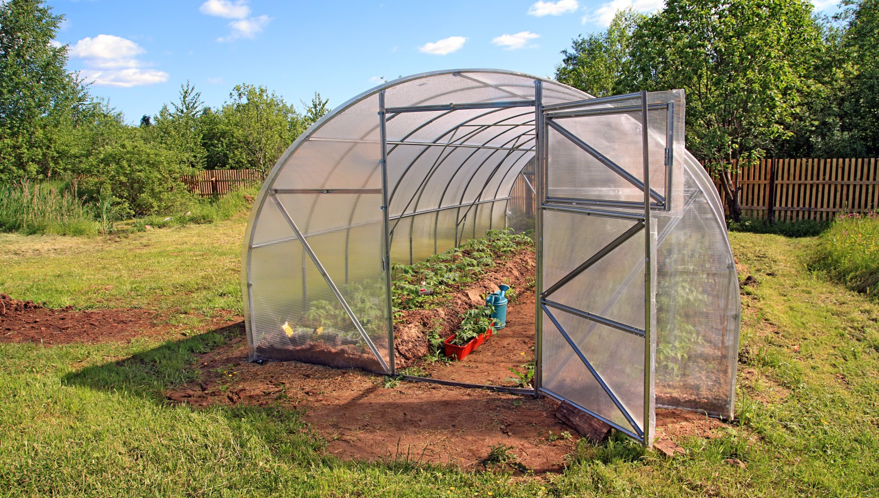

**$500!**

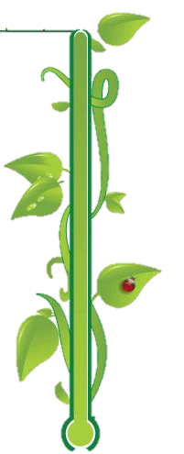

**Thanks to the generosity of Patty Wakefield-Brown, Dave and Sandra Goldman, and Peter Jemison and Jeanette Smith, the Conservation Team will be able to build a hoop house this fall! Patty Wakefield-Brown has donated in memory of her parents, Raymond “Charlie” and Barbara “Barb” Fedeli. We are extremely grateful to our donors!**

With this generous gift, the hoop house will serve as both a greenhouse for propagation and a shaded area for plant storage prior to planting. This will allow the Conservation Team to expand our efforts, increasing the amount of plant materials we will be able to use for restoration, as well as ensuring that our materials will be of a local ecotype – collected from naturally occurring species either on site or locally!

**The Conservation Team would also like thank Victor Walmart for their donation towards storage containers for seed preservation. We can’t wait to start preserving collected seeds for the winter!**

**GANONDAGAN HOLDS STATE-WIDE & FINGER LAKES INVASIVE SPECIES MANAGEMENT MEETINGS**

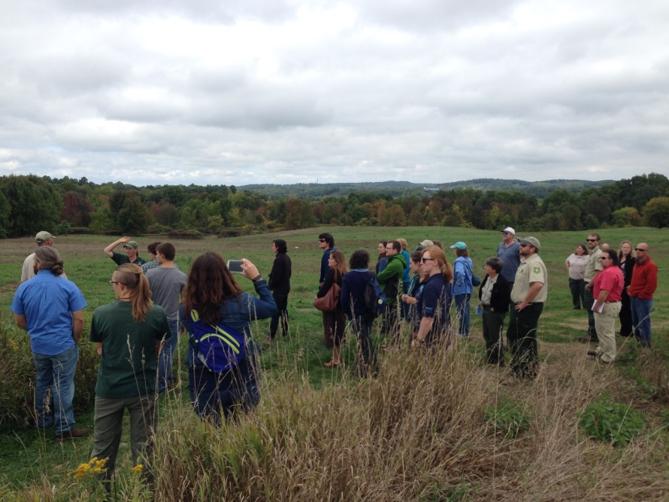

Last week, partners and leaders in invasive species management from multiple public and private organizations gathered at Ganondagan to present and discuss project updates. Ganondagan held both the Finger Lakes Partners for Regional Invasive Species Management (FL-PRISM) Fall Partnership Meeting, hosted by Hilary Mosher, and the PRISM leader meeting, where PRISM leaders from across New York State met for strategic planning.

Right: Kyle Webster, Supervising Conservation Steward, led tours of the Oak Unit restoration as an update for the GLRI grant.

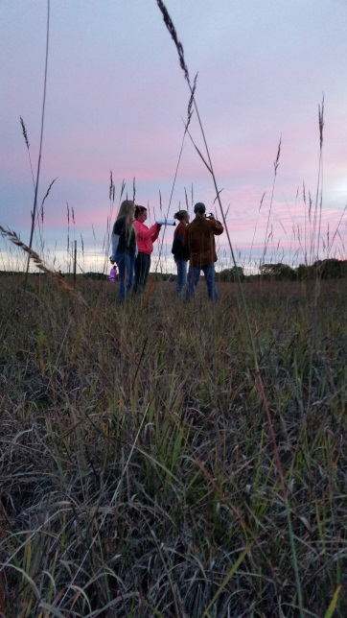

THANK YOU FOR SUPPORTING US!

Thank you to our plant material donors and volunteers for your invaluable support!

Join our Expanding Plant (& Seed) Donor List!

Victor Garden Club, Genesee Land Trust, Andy Joss, Helen Ellis, Eileen Wierzbicki, Lorie Thomas, Michael Hannen, SUNY ESF FORCES, Amy Kahn, Rosemarie Parker, Krissy Boys, Finger Lakes Native Plant Society, Patty Wakefield-Brown, the Woodruffs, Lucas Greenhouses, Frank Russell, and

Sandra Bierbrauer

So Far, We Have Reached:

**2530 volunteer hours & 20,230 dollars’ worth of donated plants**

**Check us out on the website:** [www.ganondagan.org/environmental-team](http://www.ganondagan.org/environmental-team)

**Visit our restoration areas:** [**http://ganondagan.org/files/documents/GanondaganConservationAreasMap.pdf**](http://ganondagan.org/files/documents/GanondaganConservationAreasMap.pdf)

**FORCES GATHERING**

**F**riends **o**f **R**ecreation, **C**onservation and **E**nvironmental **S**tewardship

Seven collegiate FORCES clubs, interns, and FORCES staff met at Chenango Valley State Park, outside of Binghamton for a day of workshops, networking, and fun! The FORCES Gathering provides an opportunity for members to work on the “**F**riends” and “**R**ecreation” part of the FORCES moniker, which is especially important after a busy year of “**C**onservation and **E**nvironmental **S**tewardship.” Every year, FORCES members look forward the advice imparted by Regional Biologist Tom “Grandfather FORCES” Hughes, as well as eating his delicious bacon-wrapped venison bites. We can’t wait for next year!

Kyle Webster explains compass and GPS basics at a Navigation Workshop

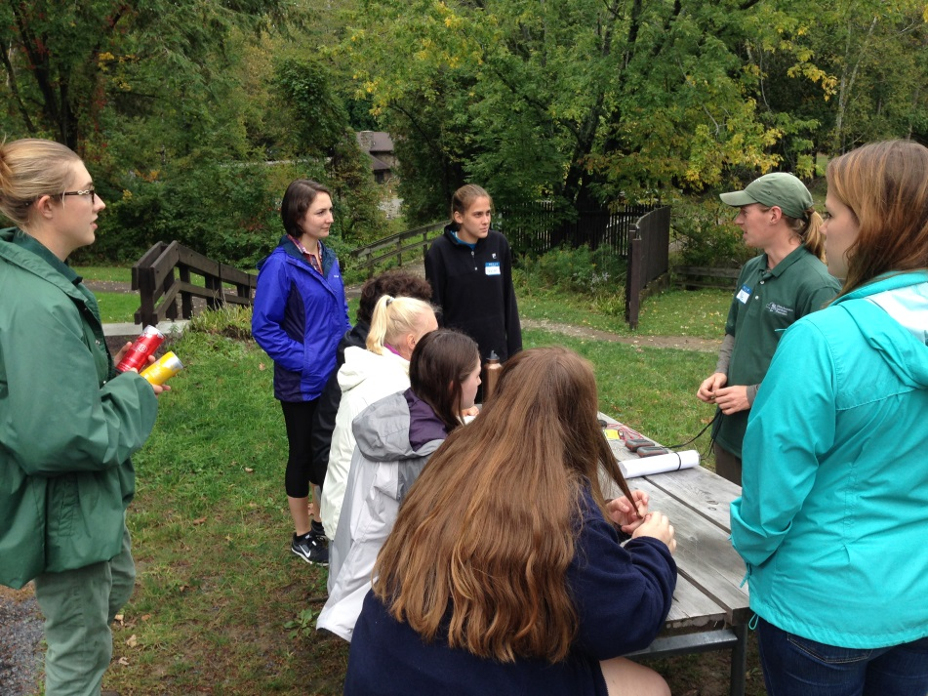

 V



FEATURED FLORA

Shagbark Hickory (*Carya ovata*)

New Fall & Winter Interns

Our dedicated intern and volunteer base is expanding! We are always on the look-out for interested interns and volunteers – we could not accomplish all that we do without them!

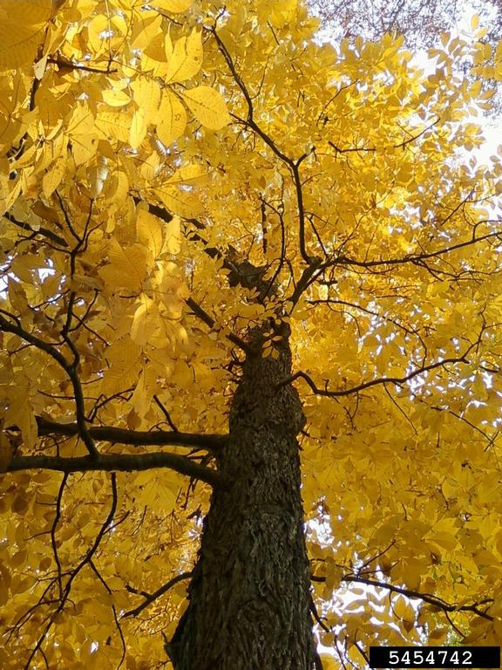

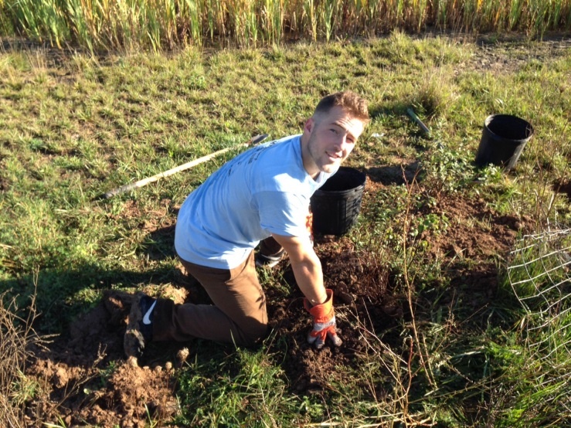

Jason Sharman, Vitalitree, Bugwood.org

Derek Boland, a senior at St. John Fisher College, is interning this season at Ganondagan and contributing to a wide range of environmental projects including seed collecting, planting, trail maintenance, and invasive removals.

Trees are just beginning to show their fall colors as the seasons change. Complementing the fall palette of red, yellows, and browns, hickories are consistently hues of golden to yellow.

For shagbark hickory, as the nights lengthen, chlorophyll begins to degrade, causing the green leaves to fade and expose the yellow colors expressed by carotenoids. This process is also influenced by variations in weather – temperature and water availability. This summer’s drought may offset color change, but we can hope for cool but above freezing weather to come for the best fall display!

Luckily for us, trees offer multiple characteristics for use in identification. Once winter finally arrives, shagbark hickory will become one of the most easily identifiable trees. Even with the absence of flowers, leaves, and delicious nuts, its shaggy bark is unmistakable.

As fall progresses into winter, take a moment to observe shagbark hickory’s progression into stunning golden hues, to when its unique peeling bark is a beautiful contrast to a snowy backdrop and the bark patterns of other trees...all visible at Ganondagan State Historic Site!

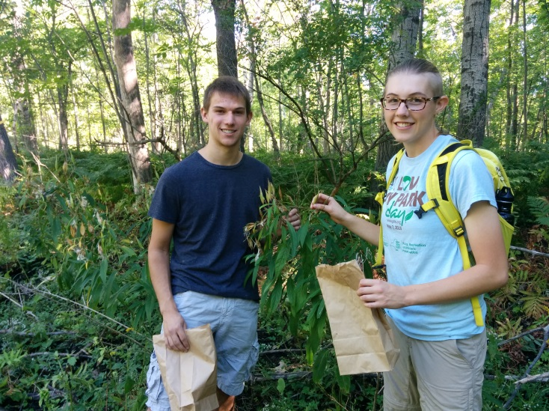

Jake Young, a student at RIT, volunteers at Ganondagan with the seed collection program, and has started a project mapping new trails on-site, incorporating GIS.

Featured Project: Ornithology at Ganondagan

*Written by: Alexis VanWinkle, Supervising Conservation Steward*

The use of canaries in coal mines is a great example of how birds can be indicators of ecosystem functionality. They indicate the environment’s integrity, on which we humans depend for clean air and water, fertile soils, and other natural resources.

Ornithology, the study of birds, at Ganondagan has expanded in recent years. The Grassland Management Area, installed in 2009, was designed based off descriptions written by European visitors in the 17th Century, and became one of few open warm-season grassland spaces in New York State. Because grasslands are dwindling, grassland bird populations are also dwindling. The hope is that as the different grassland restoration projects progress at Ganondagan, grassland birds will use the site as a nesting haven and an increase in local populations will be observed over time. There are several surveying and monitoring projects happening at Ganondagan to catalog the change in bird species composition as time progresses and projects evolve.

In 2015, the Eastern Bluebird Nest Box Monitoring Program, a program that pre-dates the Environmental Field Team, was handed over to team members. Many of the nest boxes around the Pollinator Grassland needed to be replaced, so in March an Allendale Columbia 7th grade class built over 25 boxes to be used on site. This allowed for all of the old, dilapidated boxes to be substituted. The Eastern Bluebird Nest Box Trail was relocated to the top of Fort Hill in 2016, but is still monitored weekly throughout the breeding season for Eastern Bluebirds (March-August). As grassland projects progress, the box locations will expand to cover more of Ganondagan.

Currently the dominant ornithology project is cataloging all species of birds that can be observed at Ganondagan within grassland and shrubland spaces. This project will eventually include all forested and wetland spaces as well. In June of 2015, June Summers, the Genesee Valley Audubon Society’s president, designed the beginning protocol for grassland bird surveys in the Bluestem and Hickory Units. This was a requirement for the prescribed burn to make sure that the burn wouldn’t have any adverse effects on rare or threatened grassland birds. These surveys helped determine that without a burn, grassland birds would not nest in these locations due to the large amount of plant litter covering the ground. In 2016, this surveying protocol was adapted to cover all grassland and shrubland spaces, which allows for a better snapshot of the bird activity. By the spring of 2017, the protocol will again be adapted to cover forested areas. All birds documented as using the site will be cataloged to support the designation of Ganondagan as a Bird Conservation Area (BCA).

Raptor surveys will also be added to the list of projects happening at Ganondagan. Raptors rely heavily on grasslands, especially during the winter, for food (mice, voles, moles, etc.) that live underneath the snow in open spaces. A Short-eared Owl, currently considered an endangered species within New York, was spotted within the Bluestem Unit in December of 2015. Raptors are a predatory species in most open spaces, helping control populations of rodents and small mammals, which in turn maintains proper plant compositions (through limiting herbivory).

If you are interested in helping with grassland, shrubland or forested bird surveys or raptor surveys, please send an email to: Alexis.VanWinkle@parks.ny.gov. ❖

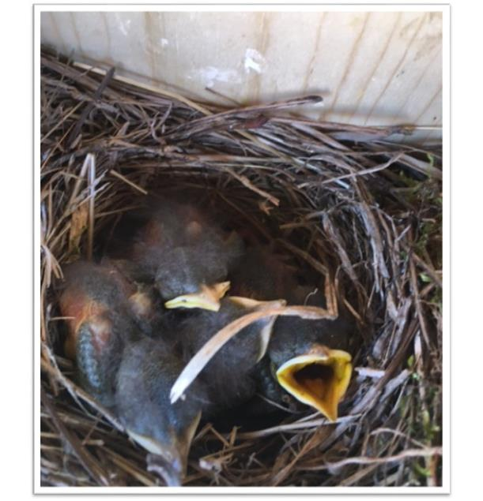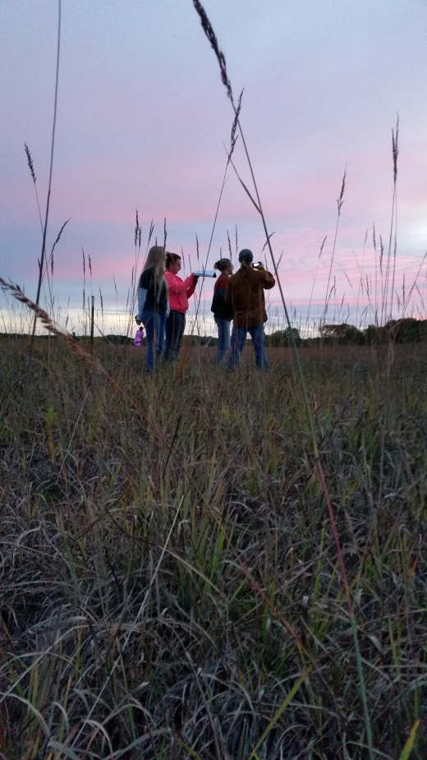

Nest Box Monitoring:

Tree Swallows Spotted 2016!

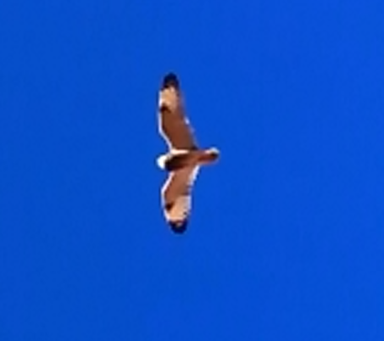

Short-eared Owl observed in the Bluestem Unit in December 2015. Photo credit: Kyle Webster

Raptor surveys in action! *Jordan Dube 2016*

WRAPPING UP THE GROWING SEASON

While this season still shows no signs of slowing down, fall is here and the growing season is reaching its end. We would like to extend a huge thank you to all who made this growing season successful– our interns, volunteers, donors, partners, and staff especially! We look forward to seeing you at our winter events:

**February:**

* February 21st (7-8pm) - Public Meeting- Ganondagan Prescribed Burn, SACC Classroom 1

*Join to learn more about the prescribed burn taking place this spring at Ganondagan’s Grassland Management Area. Community member questions are encouraged.*

* February 18th (10am-12pm) - Environmental Perspectives & Community Collaborations, SACC auditorium

*This lecture suite showcases local restoration projects and provides an opportunity for community partners with similar goals to network and engage new environmental perspectives.*

**March:**

* March 18th (10am-12pm) Winter Tree ID Workshop, EFO

*Join Kyle Webster, Supervising Conservation Steward, to learn the tricks of identifying trees in winter!*

***Have a wonderful fall and winter season! See you in the spring!***

*Have a wonderful fall and winter season. See you in the spring!*

